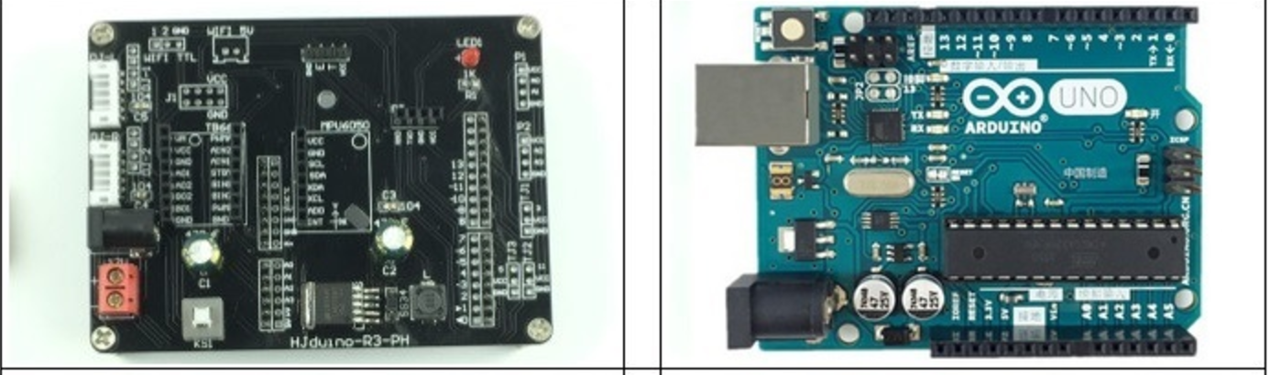

R3 balance car power board Arduino board

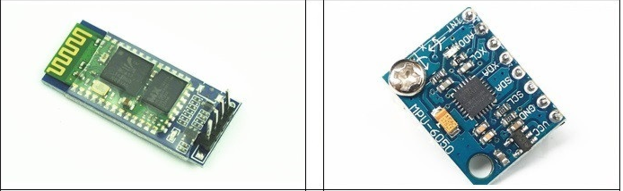

Bluetooth Board Gyro Module

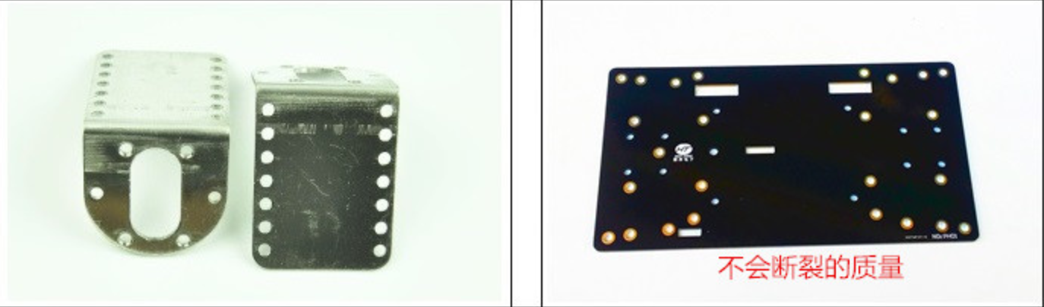

Magnetic motor fixing bracket PCB floor

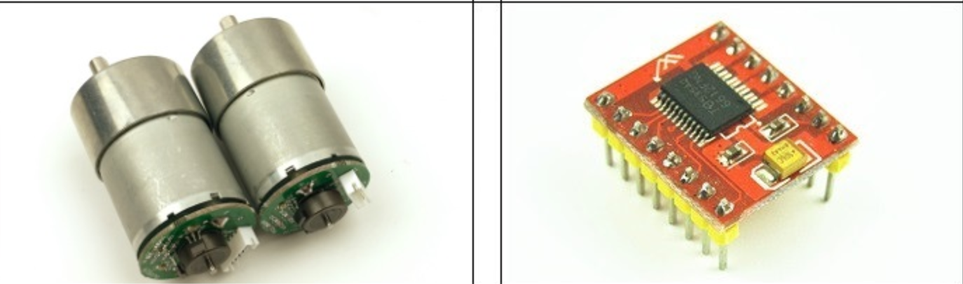

Hall Speed motor TB6612FNG

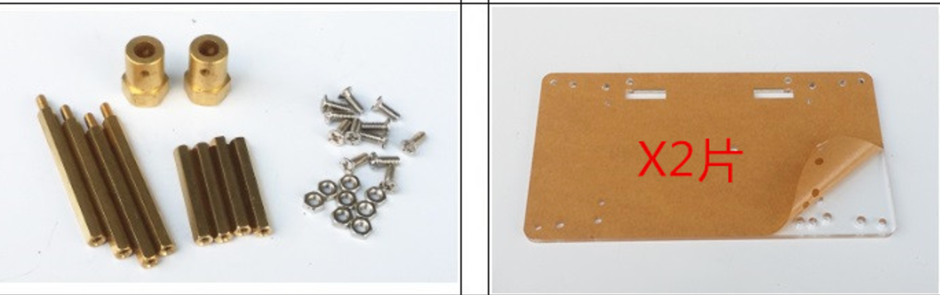

Balanced car mounting screws Plus version

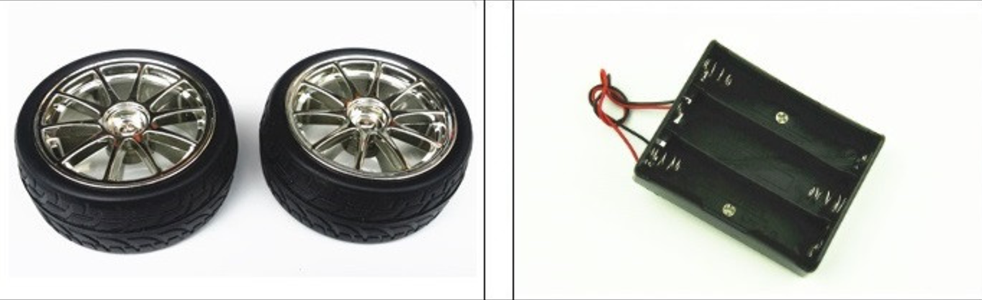

Car Wheel Buttery Box

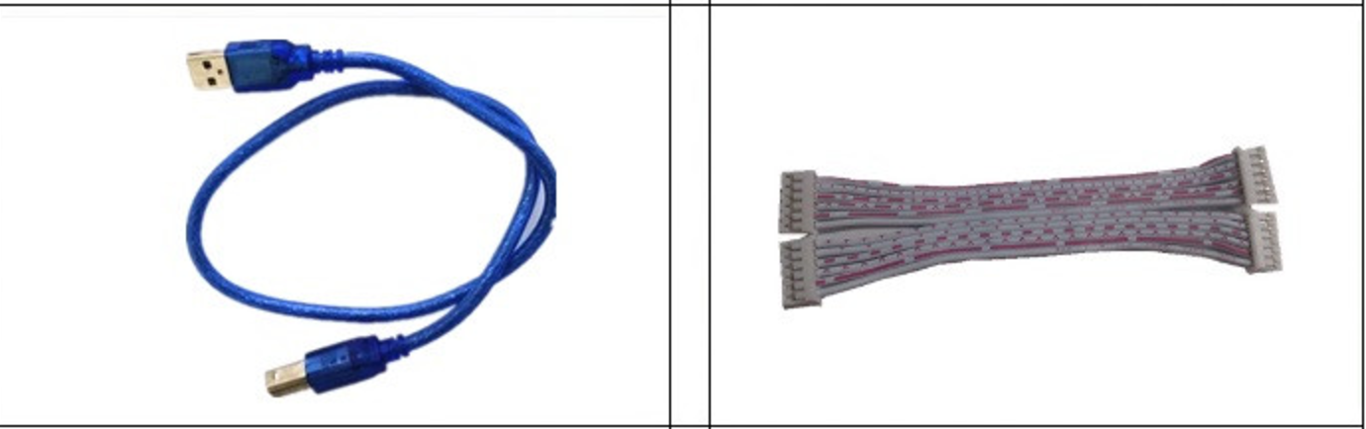

USB cable 6PCable